In this lab we will iterate through CSV files located inside a directory and store all the data inside it into Sql Sever

|  |  |  |
| --- | --- | --- |
| **Step 1: Prepare the database** Same ContainerDemo database and Customer table will be used. Make sure to truncate it.  Step 2: Create SSIS project  Create new SSIS project using SQL Server data tools **Step 3: Create data Folder and Data Files** Create 3 CSV Files with some data and put them in the some folder. **Step 4: Create variable** Create a new variable called “FilePath” | https://www.codeproject.com/KB/database/789618/31.png |  |

|  |  |
| --- | --- |
| **Step 5: Add and configure “for each loop container”**  1. Add For each loop container to control flow 2. Double click the container to open “Foreach loop editor” 3. Change selection in left section from General to collection. 4. Set Enumerator as “ForEach File Enumerator” 5. Select Folder Path 6. Put “*.csv” in the Files textbox 7. Change selection from Collection to variable mapping. 8. https://www.codeproject.com/KB/database/789618/33.pngSet variable to one created in above step and Index to 0   https://www.codeproject.com/KB/database/789618/32.png |  |

1. Click Ok.

Step 6: Create dataflow task

When it comes to data transfer, data flow task is the only choice. Take “data flow task” from toolbox and add it inside the container.

Step 7: Add connection manager

1. Add Ado.net connection Manager and configure it to point ContainerDemo database
2. Add Flat File Connection Manager and explicitly point it to one of the files in the directory (data directory)

Step 8: Configure source and destination inside dataflow task.

1. Double click the “data flow task”. It will take you to dataflow tab
2. Add Flat file source and double click it to open Flat File source editor.

Set Connection manager to “flat file connection” created in last step.

1. Add Ado.Net destination
   1. Connect flat file source to this destination using “dataflow path”
   2. Double click the Ado.Net destination top open “Ado.Net destination editor”
   3. Set Connection manager to “Ado.Net connection” created in last step.
   4. Select table as Customer.
   5. Navigate to mapping section and make sure mapping is proper.

**Note:** You might be thinking “We are going to perform looping over the files, then why we configured source to single file”. Answer is Relax!! J We have not done yet. We connected our source to one of the file because by doing so, we got the idea about source file structure and mapping was possible.

Step 9: Make connection dynamic

1. Right click the Flat file connection and go to properties
2. Find the expression property and click the 3 dot button. It will popup “property expression editor”
3. Select property as ConnectionManager and click the 3 dot button to set expression

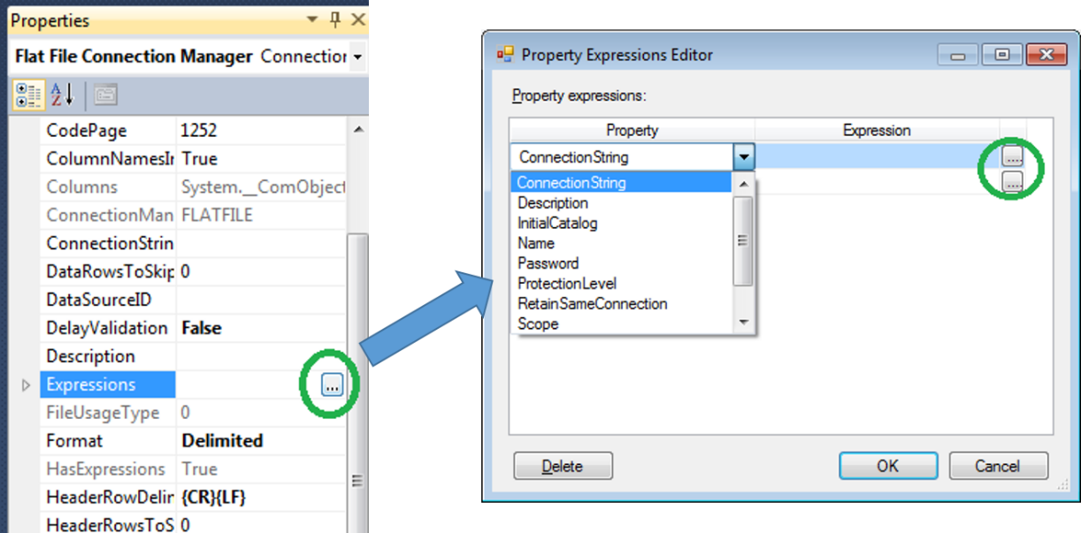

1. “Expression builder” window will popup. From the “Variable and parameter” section, take FilePath variable created in one of the previous step and drag it to “Expression” section.

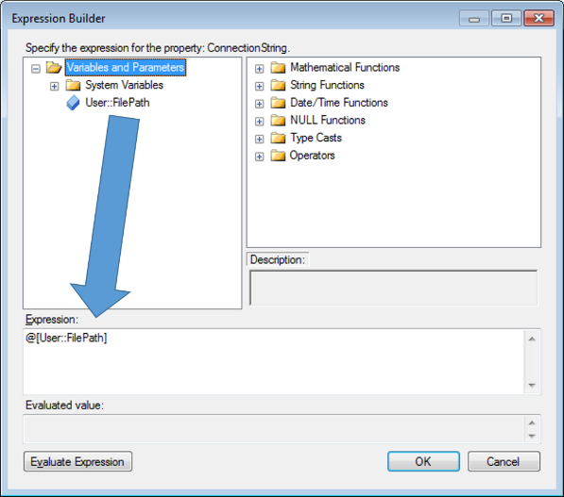

1. Click Ok to close the “expression builder”. Click Ok again to close the expression property editor window.

### Step 10: Execute and Test the application

Press F5 and check the output

